

Cloud Monitoring Heart Beat Sensor
Data For Worker and Soldier in Hostile Conditions

Report submitted to GITAM (Deemed to be University) as a partial fulfillment of the requirements for the award of the Degree of Bachelor of Technology in ELECTRONIC AND COMMUNICATION ENGINEERING

Name Register Number
- S SHESHU - BU22EECE0100088
- PRAJWAL KUMAR- BU22EECE0100444
- SHRAVANI A - BU22EECE0100447
-_

DEPARTMENT OF ELECTRICAL, ELECTRONICS AND COMMUNICATION ENGINEERING
GITAM SCHOOL OF TECHNOLOGY GITAM (DEEMED TO BE UNIVERSITY) BENGALURU -561203
NOV 2025

DECLARATION

We declare that the project work contained in this report is original and it has been done by me under the guidance of my project guide.

Name: Dr. Kshitij Shakya Date: 2/09/2025
Signature of the Student: S SHESHU, PRAJWAL KUMAR, SHRAVANI A

Department of Electrical, Electronics and Communication Engineering GITAM School of Technology, Bengaluru-561203



CERTIFICATE

This is to certify that (S SHESHU, PRAJWAL KUMAR, SHRAVANI A) bearing (Regd.No.:BU22EECE0100088,BU22EECE0100444,BU22EECE0100447)has
satisfactorily completed Mini Project Entitled in partial fulfillment of the requirements as prescribed by University for VIIth semester, Bachelor of Technology in “Electrical, Electronics and Communication Engineering” and submitted this report during the academic year 2025-2026.

[Signature of the Guide] [Signature of HOD]

Dr. Kshitij Shakya Dr. Prithvi Sekhar Pagala

Table of contents
Chapter 1: Introduction 1
  - Overview of the problem statement 1
  - Objectives and goals 1
Chapter 2 : Literature Review 2
Chapter 3 : Strategic Analysis and Problem Definition 3
  - SWOT Analysis 3
  - Project Plan - GANTT Chart 3
  - Refinement of problem statement 3
Chapter 4 : Methodology 4
  - Description of the approach 4
  - Tools and techniques utilized 4
  - Design considerations 4
Chapter 5 : Implementation5
  - Description of how the project was executed 5
  - Challenges faced and solutions implemented 5
Chapter 6: Results 6
  - outcome 6
  - Interpretation of results 6
  - Comparison with existing technologies 6
Chapter 7: Conclusion 7
Chapter 8 : Future Work 8
References 9

Chapter 1: Introduction

Overview of the problem statement
    - Most existing heartbeat monitoring systems are limited to local displays
(OLED/LCD) and do not provide remote/cloud access.
    - Lack of continuous monitoring in hostile or remote environments (battlefields, disaster zones, mines).
    - Soldiers and workers in extreme conditions are exposed to high risk
without real-time health tracking.
    - Existing research often focuses on laboratory or hospital setups, not on

field-deployable, IoT-enabled systems.
    - No integrated system that combines pulse sensing + cloud storage + real- time visualization for proactive health response.

Objectives and goals

The objective of this project is to design and implement a reliable cloud-based heart rate monitoring system that continuously measures and analyzes the heartbeat of workers and soldiers operating in hostile or remote environments. By integrating pulse sensors with IoT platforms, the system aims to:
- Ensure real-time monitoring of vital signs.
- Enable remote access to health data through cloud storage.
- Provide early alerts in case of abnormal heart activity.
- Enhance safety, decision-making, and rapid medical response in high-risk conditions where traditional healthcare access is limited.

Main Goals
- Continuous monitoring of heart rate using pulse sensors.
- Real-time transmission of heartbeat data to the cloud for remote access.
- Visualization of health status through OLED display and cloud dashboards.
- Early detection of abnormal heartbeat patterns with instant alerts.
- Reliable operation in hostile and remote environments.

Additional Goals
- Ensure portability and low power consumption for field deployment.
- Provide secure data logging for long-term health analysis.
- Enable scalability to support multiple users (workers/soldiers) simultaneously.

Chapter 2 : Literature Review

Title and Author | Problem statement | Methodology | Result
Real-Time Health Monitoring and Tracking System of Soldiers Using IoT Aradhana Sahu, Pranali Ghotekar, Shrinivas Patil, Rutuja Ghodke | Soldiers in remote/hostile areas face health risks without immediate medical aid, and there is no system for continuous real-time monitoring of their health and location. | Wearable sensors for heart rate, ECG, and temperature  - Arduino + GPS + GSM (SIM808) to  collect & transmit data  - Soldier node → Squadron node → Control center node  - Panic button + alert system for emergencies | System enables real- time monitoring of soldier’s health & location, generates emergency alerts, and improves safety and battlefield decision- making.
Online Monitoring Health Station Using Arduino Mobile Connected to Cloud service: “Heart Monitor” System Eman Abed-Alkareem Karajah, Isam Ishaq (Al-Quds University, Jerusalem, Palestine) | Many patients need continuous monitoring of vital signs (heart rate, body temperature). Existing solutions are costly, require hospital visits, and lack real-time remote monitoring. | Developed an Arduino Uno-based circuit with heart rate sensor (SN- 11574), LM35  temperature sensor, HC-05 Bluetooth module. Data is sent to an Android app, displayed, stored in Google Sheets cloud, with alarms and automatic calling after 5 abnormal readings. | The proposed “Heart Monitor” system achieved 97.4% accuracy compared to an ECG device. It provides real-time monitoring, alarm alerts, and automatic calls during abnormal readings.

Title and Author | Problem statement | Methodology | Result
Health Monitoring System  Prof. R. R. JainNidhi GuptaAnusha VartakRevati Tamboli | Bedridden and critical care patients require constant monitoring of vital parameters. Since doctors or relatives cannot be present all the time, delays in detecting issues like sudden temperature changes, falls, or diet irregularities can be life- threatening. Thus, a system for remote and continuous health monitoring is  essential. | The system uses temperature, accelerometer, and vibration sensors to monitor patients. An embedded system processes the data and sends it via Bluetooth to a smartphone app, which tracks temperature, detects falls, monitors diet, and sends alerts. An admin PC stores patient data and diet schedules for doctor  reference. | The system monitors body temperature, diet, and falls, sending alerts to doctors or relatives for timely response. While the prototype works, it needs further optimization for compactness and broader use.
IoT Based Health Monitoring System Prajoona Valsalan, Tariq Ahmed Barham Baomar, Ali  Hussain Omar Baabood. | Healthcare faces challenges in timely diagnosis, especially during epidemics or in rural areas with limited facilities.  Frequent hospital visits are costly, so a remote system is needed to monitor vital signs and share data with doctors for proper diagnosis. | An IoT-based health monitoring system was built with sensors to track vital signs, processed by a microcontroller and sent to the cloud.  The data, stored on a medical server, is accessible to doctors for remote diagnosis using a rule-based system. | The prototype successfully monitored and transmitted sensor data to the IoT platform, enabling doctors to remotely diagnose patient conditions. This reduced hospital visits and supported timely intervention, proving effective for epidemics and rural  healthcare.

Title and Author | Problem statement | Methodology | Result
Automated Remote Cloud-Based Heart Rate Variability Monitoring System Ahmed Faeq Hussein, Arun Kumar N, Marlon Burbano- Fernandez, Gustavo Ramírez-González, Enas Abdulhay, Victor Hugo C. De  Albuquerque | Lack of effective heart health monitoring in remote areas; need for continuous, secure patient tracking | Wearable ECG sends data to the cloud, analyzed for heart rate variability using secure algorithms and web | High accuracy (>99%), enables easy remote monitoring and secure data access for doctors and patients
HealthCloud: A system for monitoring health status of heart patients using machine learning and cloud computing Forum Desai, Deepraj Chowdhury, Rupinder Kaur, Marloes Peeters,  Rajesh Chand Arya, Gurpreet Singh Wander, Sukhpal Singh Gill,  Rajkumar Buyya | Early heart disease detection and monitoring is challenging; existing self- diagnosis and home systems lack accuracy and reliability | Mobile application uses machine learning models (SVC, KNN, NN, LR, GBT) and cloud computing (Google Firebase) for heart disease prediction based on user data | Logistic Regression was most accurate (85.96%), efficient and responsive; system enables reliable health assessment and  real-time monitoring for patients

Chapter 3 : Strategic Analysis and Problem Definition

SWOT Analysis:

Strengths
- Real-time monitoring
- Cloud access
- Alerts for safety

Weaknesses
- Needs internet
- Battery limit
- Sensor errors

Opportunities
- Use in army, mines, rural health
- Can add AI/ML
- Growing wearable market

Threats
- Competition (smartwatches)
- High cost
- Data security issues

Project Plan - GANTT Chart
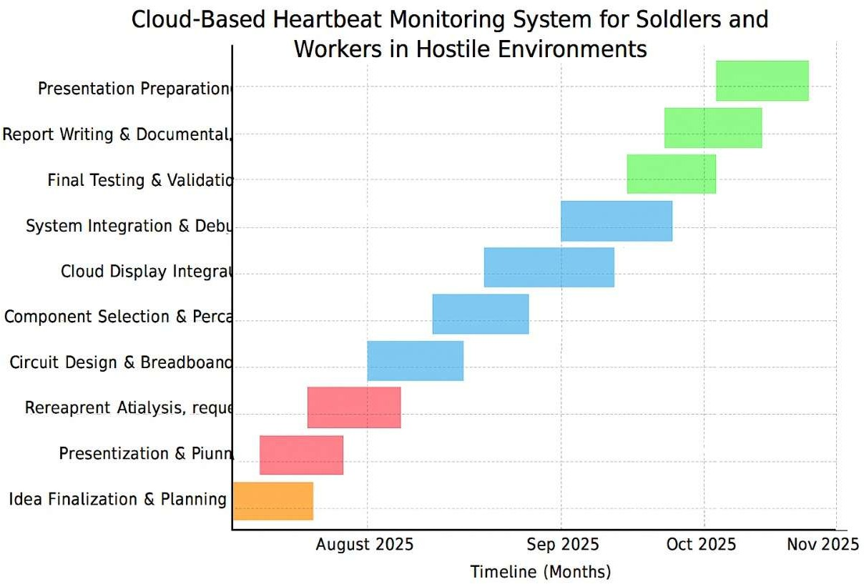

Chapter 4 : Methodology

Sensor Data Acquisition

Pulse sensor (HW-827) measures heartbeat signals.

DHT11 sensor collects temperature & humidity for health/environmental monitoring. Signals are passed through ADS1115 (ADC) for accurate digitization.
Pre-Processing & Display

Node MCU ESP8266 receives digitized data from ADS1115.

Real-time ECG-like waveform is generated and displayed on OLED for local monitoring. Potentiometer used to adjust waveform scaling on the OLED.
Cloud Transmission

Node MCU connects to Wi-Fi and transmits heartbeat and environmental data to a cloud database (e.g., Firebase/IoT platform).

Ensures continuous remote accessibility. Remote Monitoring & Alerts
Data can be accessed via a web app/dashboard.

Alerts triggered in case of abnormal heart rate or dangerous conditions. Validation & Testing
Test system on breadboard setup using jumper wires.

Verify accuracy of sensor readings and stability of cloud updates. Adjust resistor & potentiometer values for signal noise reduction.

Chapter 5 : Implementation coe
#include <Wire .h>
#include <Adafruit _ GFX. h> #include <Adafruit_SSD1306.h>

#define SCREEN_WIDTH 128
#define SCREEN_HEIGHT 64
Adafruit_SSD1306 display(SCREEN_WIDTH, SCREEN_HEIGHT, &Wire, -1);

#define ANALOG_PIN A0 // Node MCU Analog pin #define MAX_POINTS 128 // OLED width = 128 pixels int y Values[MAX_POINTS]; // store waveform points int index Pos = 0;

void setup() {
Serial .begin(115200);

if (!display .begin(SSD1306_SWITCHCAPVCC, 0x3C)) { Serial . print ln (F("SSD1306 allocation failed"));
for (;;);
}
display. Clear Display(); display .display();
}
void loop() {
// Read sensor / potentiometer value
int sensor Value = analog Read(ANALOG_PIN);

Chapter 6: Results

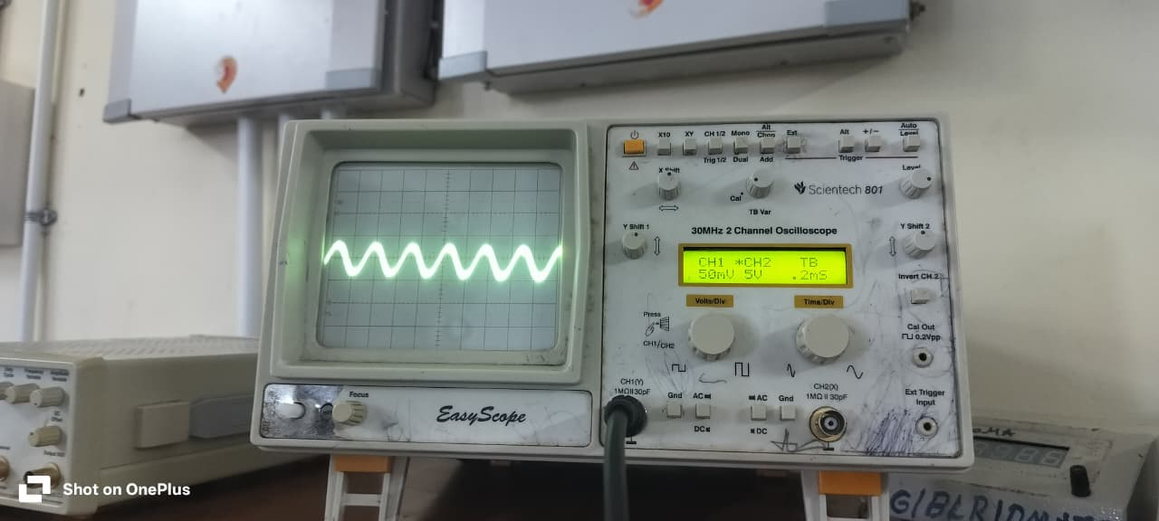

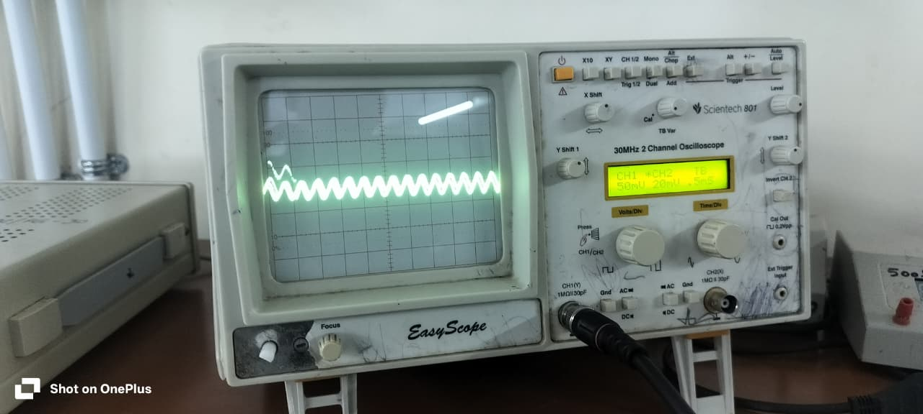

Chapter 7: Conclusion

- The proposed system successfully integrates Pulse Sensor + ADS1115 + Node MCU + OLED + Cloud to provide real-time heartbeat monitoring.

It overcomes the limitation of existing systems by enabling remote cloud access rather than just local display.
- Ensures safety and timely response for soldiers and workers in critical environments.

Chapter 8 : Future Work

- Extend the system to support multiple users simultaneously

(monitoring a fullsquad/unit).
- Improve cloud dashboard visualization (clearer waveforms, alerts, data history).

Add offline storage on NodeMCU8266 (SD card) for backup when internet/cloud is unavailable.
- Enhance security & encryption for soldier/worker health data.
- Miniaturize the hardware into a wearable device (armband).

References

  - Pantelopoulos and N. G. Bourbakis, “A survey on wearable sensor-based systems for health monitoring and prognosis,” IEEE Transactions on Systems, Man, and Cybernetics, Part C (Applications and Reviews), vol. 40, no. 1, pp. 1–12, 2010.

J. Heikenfeld et al., “Wearable sensors: modalities, challenges, and prospects,” Lab on a Chip, vol. 18, no. 2, pp. 217–248, 2018.

P. Gope and T. Hwang, “BSN-Care: A secure IoT-based modern healthcare system using body sensor network,” IEEE Sensors Journal, vol. 16, no. 5, pp. 1368–1376, 2016.

ThingSpeak IoT Platform Documentation, “IoT Analytics for Sensor Data,” MATLAB & Simulink Solutions, [Online].
Available: https://thingspeak.com








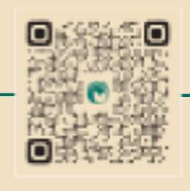

Bengaluru City Office No 5/1, First Floor, Prestige Terraces, Union Street, Infantry Road, Bengaluru - 560003 Karnataka, India
[ Projet Title ]



[ Projet Title ]

